

BSMT 39th Annual Microbiology Conference
02 May 2024
Rapid diagnostics - warts and all

Speaker profiles

Dr Luke Moore,

Consultant in Infectious diseases, Chelsea and Westminster NHS Foundation Trust
Dr Luke Moore is a clinical microbiologist and infectious disease physician currently working in the Chelsea and Westminster Hospital. Holding a PhD and two masters degrees in public health and clinical microbiology Dr Moore has both an active clinical role and significant research and teaching responsibilities. He has a particular interest in critical care infections and antimicrobial resistance with research interests currently focussing on the epidemiology and control of outbreaks and antimicrobial stewardship. Dr Moore will be discussing the assessment and value of rapid diagnostics.

Dr Jesus Rodriquez-Manzano,

Associate professor Department of infectious disease Imperial College, London.
Dr Jesus Rodriguez-Manzano is an associate professor at Imperial College currently working within the Centre for Antimicrobial Optomisation as deputy director. Following completion of his PhD in Microbiology and Biotechnology at the University of Barcelona Dr Rodriguez-Manzano pursued several post doctoral positions working at Caltech in the USA before his current role at Imperial. His research interests focus on developing and implementing innovative methods of molecular diagnosis and antimicrobial resistance but also span many other areas including machine learning and the application of POCT solutions in low and middle income countries. Dr Rodriguez-Manzano will be presenting on the topic of next generation molecular diagnostics.
Dr Michelle Cole,
Principal Clinical Scientist, UK Health Security Agency STI Reference Laboratory
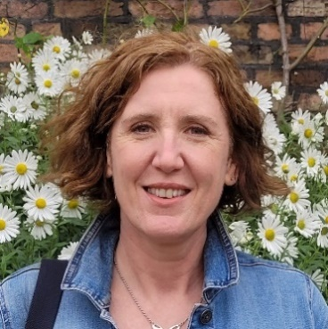
Michelle Cole is a Clinical Scientist and Fellow of the Royal College of Pathologists who works in the national STI reference laboratory that delivers UKAS-accredited STI reference services. Michelle has a wealth of experience in STI AMR, diagnostics and surveillance and works closely with UK Health Security colleagues to deliver the world-class national gonococcal resistance to antimicrobial surveillance programme (GRASP) and the M. genitalium antimicrobial resistance surveillance (MARS) programme. Michelle has additionally developed several international surveillance programmes over the years including the European gonococcal (Euro-GASP) and European LGV surveillance programmes and also has a keen interest in STI and AMR research. Michelle will be discussing the molecular approach for STI AMR surveillance.
Ivor Mitchelmore.
Chief Biomedical Scientist, Department of Microbiology, Luton and Dunstable Hospital (Retired)
Ivor Mitchelmore is a now retired Chief Biomedical Scientist previously having worked at the Luton and Dunstable Department of Microbiology. Since retirement Ivor has continued to contribute to the field of microbiology and has been actively involved in the development of the microbiology service in a small remote mission hospital in West Bengal, India. Ivor has been actively co-ordinating and sourcing necessary equipment as well as annually visiting the hospital to deliver much needed training and support over several years now. Ivor will be presenting his perspective on this work in what will likely be a fascinating insight into this complex and challenging process.
Dr Adela Alcolea-Medina,
Clinical Scientist Microbiology, Guys and St Thomas’ Hospital, Synnovis.
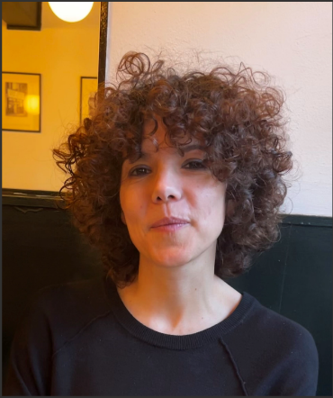
Dr Adela Alcolea-Medina qualified in Pharmacy in 2003 at Universidad de Valencia, Valencia Spain. She specialised in Clinical Microbiology and Parasitology at Hospital 12 de Octubre, Madrid becoming Consultant in Clinical Microbiology. In 2008 she obtained DEA (MPhil) at Universidad Compluense de Madrid. She worked in Spain as a Consultant Clinical Scientist and from 2017 has worked as a Clinical Scientist in the UK in NGS, metagenomics and Mycobacteria.
Dr Alcolea-is currently working as a Lead Next Generation Sequencing in Infection Sciences at Guys and St Thomas’ Hospital (Synnovis), implementing the use of Nanopore Technology for Metagenomics, whole genome sequencing and AMR
Dr Alicia Demirjian,
Clinical lead, Antimicrobial Resistance and Prescribing, UKHSA.
Consultant in paediatric infectious diseases and immunology, Evelina London Children’s Hospital

Dr Demirjian qualified from the American University of Beirut in 2005 and completed her paediatric and infectious diseases training at Boston Children’s Hospital. Having previously served as an epidemic intelligence service officer at the US CDC, Dr Demirjian now leads UKHSA’s antimicrobial resistance and prescribing team. Her research interests include the epidemiology of antimicrobial use and outbreak investigation and at this year’s BSMT meeting will be discussing the 2024-2029 National Action Plan to address antimicrobial resistance.

